Historical Perspective of Immunology

Immunology is the study of the immune system and is a very important branch of the medical and biological sciences. The immune system protects us from infection through various lines of defense. If the immune system is not functioning as it should, it can result in disease, such as autoimmunity, allergy and cancer. The immune system is a complex network of cells and proteins that defends the body against infection. The immune system keeps a record of every microbe it has ever defeated so it can recognize and destroy the microbe quickly if it enters the body again.
Historical Perspective of Immunology:

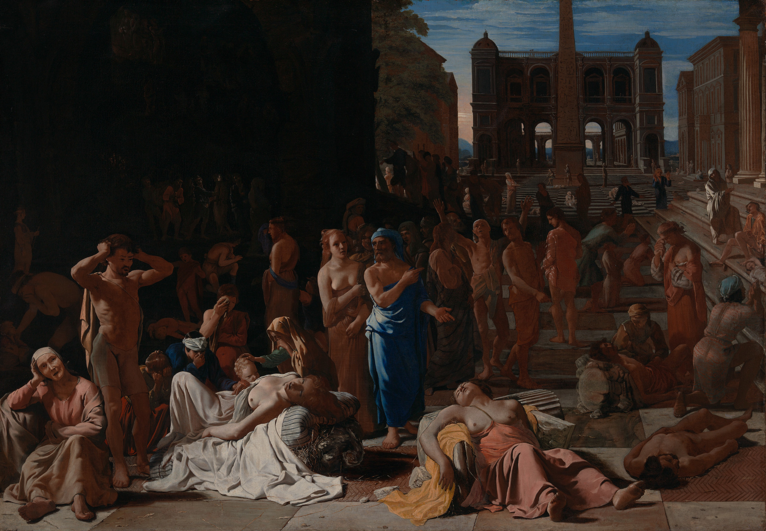
“Immunis” is a Latin word which means” exempt”. The term “Immunology” is derived from it. At first use of immunology was seen in history at the time of Plague in Athens. Thucydides who is a historian of Peloponnesian war mentioned that only those who have recovered from the plague could nurse the sick because they wouldn’t contract the disease again. They were doing it because we know today that immune system keeps the history of microbes, it encounters. So the exposure on second time will not be fatal to them. In 15 centuries, Chinese and Turks tried to prevent smallpox by using dried crusts from smallpox pustules. They did it by inhaling or inserting it to the cuts in skin. On seeing positive results, a British ambassador in Constantinople tried this on her kids. Edward Jenner stated that introducing fluids from a cowpox pustule into people might protect them from smallpox. He made this observation from the fact that milk maid who has contracted the cow pox disease were immune to severe smallpox. He reasoned that it can be a way to protect people from smallpox. He experimented on an 8-year-old boy by inoculating him with cowpox and then with smallpox. As he predicted that boy did not develop smallpox. This proved his theory.
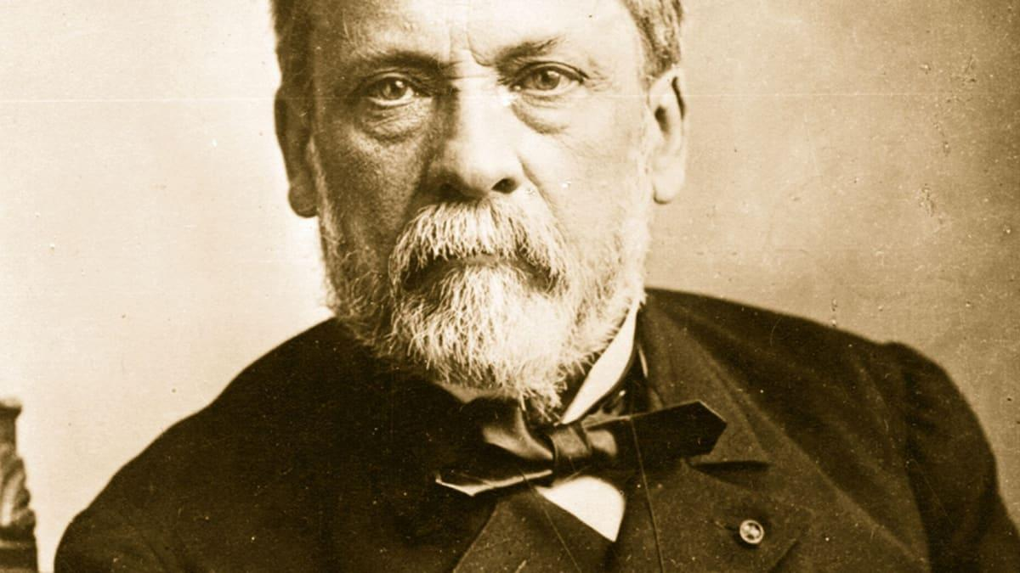
Louis Pasteur grew bacteria that causes cholera and injected it in chickens, which developed fatal Cholera. He resumed the experiment after his vacation and used old cultures to inoculate chickens. They became sick but recovered from it. He concluded that weak or attenuated strains can be used to provide immunity against the disease. Pasteur called those weak attenuated strains as “Vaccine”. “Vacca” is a Latin word for “cow”. He named it vaccine in honor of Edward Jenner’s work.
Pasteur performed experiment on two group of sheep, using “Bacillus anthracis”. He used heat killed bacteria to inoculate one group of sheep. Then he used virulent strains on both vaccinated and unvaccinated groups. He found that only the vaccinated group survived the virulent strain. This was start of the discipline “Immunology”. Pasteur administered his first vaccine to a boy who was bitten by rabid dog. This vaccine is one of the few vaccines that can be successful when administered shortly after exposure if virus has not reached the central nervous system. That boy lived and later became the care taker of the Pasture Institute which was opened in 1887.
Immunology is above more than just infectious diseases and vaccines. It is used for treatment to boost, inhibit or redirect efforts of immune cells to treat different diseases for example Autoimmune diseases, Cancer, Allergy and Other chronic disorders. It highlights the interconnected nature of body systems, providing insight into areas such as Cell Biology, Human genetics and metabolism.
Humoral And cellular Immunity Theory
Some scientists thought that immunity is mediated by cells while other argued that it is a soluble agent. In 1890, Emil Von Behring and Kitasato won Nobel prize for demonstrating that serum (non cellular) component recovered from coagulated blood of previously diphtheria immunized people could transfer the immune state to unimmunized people. He explained that when serum of people who are immunized for diphtheria, is transferred to unimmunized people will provide them the same immunity. Antitoxins, Precipitin, Agglutinin and antibodies are example of humoral immunity. Elie Metchnikoff demonstrated that cells also contribute to immune state of animals for example: Phagocytes.
In 1900, Jules Bordet expanded concept that any foreign material can serve as antigen. Karl stated that any non-self-organic material could induce production of antibodies. Paul Ehrlich proposed a theory that cell expresses different receptors which can bind to infectious agents. In his initial theory, the cell is pluripotent in that it expresses several different receptors or side chains, all with different specificities. If an antigen encounters this cell and has a good fit with one of its side chains, synthesis of that receptor is triggered, and the receptor will be released.
According to Ehrlich’s theory, the specificity of the receptor was determined in the host before its exposure to the foreign antigen, and therefore the antigen selected the appropriate receptor. Ultimately, most aspects of Ehrlich’s theory would be proven correct, with the following minor refinement: instead of one cell making many receptors, each cell makes many copies of just one membrane-bound receptor (one specificity). An army of cells, each with a different antigen specificity, is therefore required. The selected B cell can be triggered to proliferate and to secrete many copies of these receptors in soluble form (now called antibodies) once it has been selected by antigen binding.
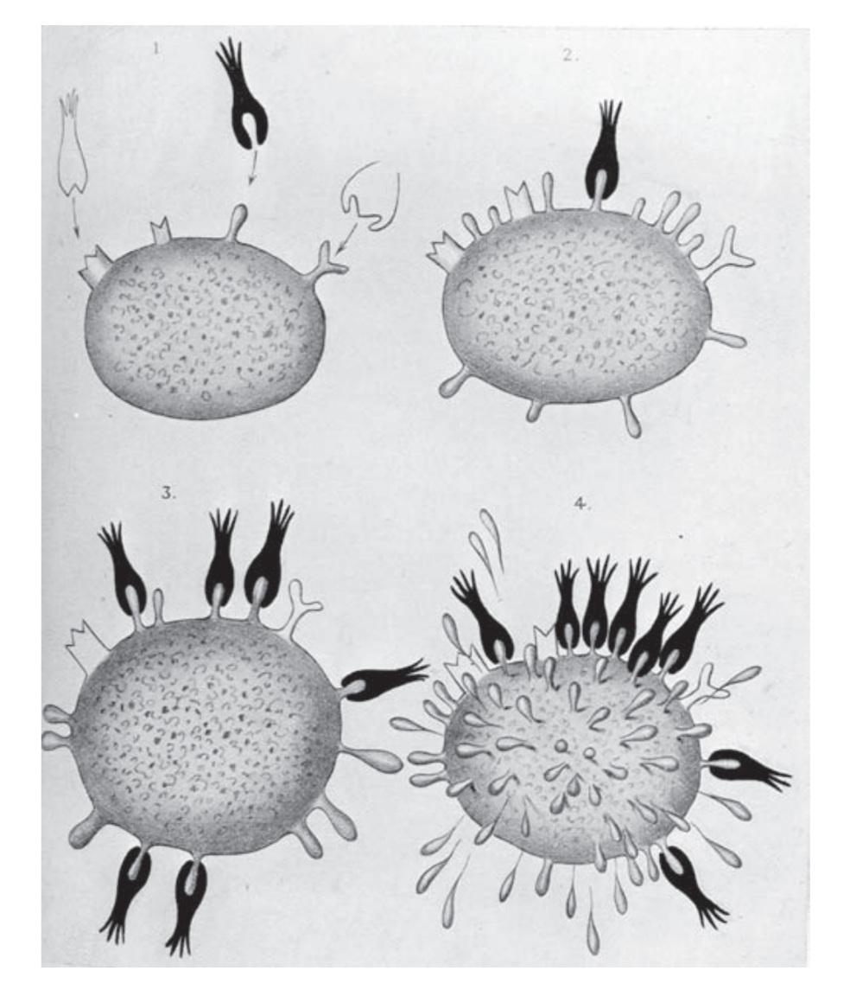
Another theory proposed for recognition of foreign substances was that a particular antigen would serve as a template, around which antibody would fold. This Instructional theory was postulated by Friedrich Breinl and Flex.
The Clonal Selection Theory:
B cells produce antibodies, a soluble version of their receptor protein, which bind to foreign proteins, flagging them for destruction. T cells, which come in several different forms, also use their surface-bound T-cell receptors to sense antigen. These cells can perform a range of different functions once selected by antigen encounter. Which includes secretion of soluble compounds to aid other white blood cells (such as B lymphocytes) and the destruction of infected host cells.
The humoral response involves interaction of B cells with foreign proteins, called antigens, and their differentiation into antibody secreting cells. The secreted antibody binds to foreign proteins or infectious agents, helping to clear them from the body. The cell mediated response involves various subpopulations of T lymphocytes, which can perform many functions, including the secretion of soluble messengers that help direct other cells of the immune system and direct killing of infected cells.
